With the support of

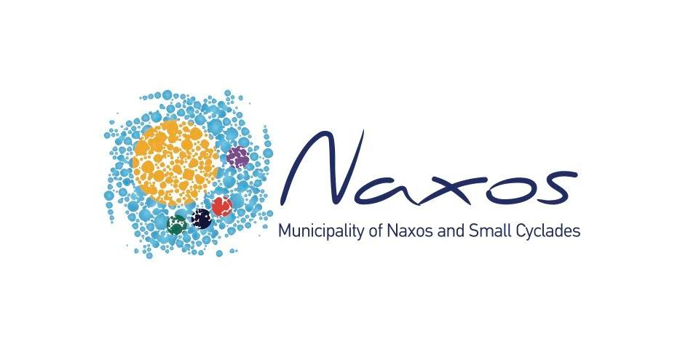

**A GARDEN FOR THE UNSEEN**

The encounter with Camilla Kielland's works confronts the viewer with compositions of enigmatic intensity, imbued with an almost anarchic expressiveness. Her aesthetic is built on a free, sentimental gesture that does not obey conventions but functions as a personal language of revelation and inner exploration.

Her artistic production is organized around three distinct but dialectically linked themes: portraits, anthropomorphic hybrid forms and drip-scapes. Taken together, the works constitute a world of images where the visible merges with the invisible, the recognizable is eroded by the uncanny, and the surface becomes a site of psychic and dimensional oscillations.

In the portraits –small-scale works with a limited, earthy palette– the initial attempt at an abstract approach is discernible. The eyes, rendered with persistence, become the focus of the composition, carrying an underlying tension. The surface is structured in successive layers, through gestural interventions, scraping with a use of a spatula, suggesting a process of revealing and at the same time concealing: as if the face emerges through the material itself. Here, the representation is not aimed at imitating external features, but at bringing out an esoteric, existential presence. The human element is present, but its ambiguity and the absence of specific identifiers lead us to a different reading —more reflective than descriptive.

The second section with the anthropomorphic entities shifts the interest from abstraction to mythical allegory. Bodies with animal and human characteristics form figures that seem to move on the borderline between a real and a dream world. These are figures that converse with the notion of multiple identities, hybridity and the non-human element. Their iconography is imbued with an archetypal, animistic energy, with references to totems, archaic masks or surrealist rituals. They are often accompanied by guiding animals, underlining man's dialectical relationship with the primordial and the unknown. The notion of the *uncanny*, of *openness of attraction*, becomes structural here: the viewer is confronted with something familiar, which nevertheless remains inscrutable.

The morphoplastic language enhances the psychological depth of the works. The use of strong contrasts between light and dark fields isolates the figures, giving them drama and intensity. The texture is rich, almost sculptural, with layering that reveals persistent psychic imprints.

On a theoretical level, we can recall Emmanuel Lévinas' words about the person as the *infiniment autre*, as the *infinite Other* that always escapes full understanding. The gaze of the face establishes an existential relationship with the viewer, a silent dialogue that transforms the viewer into a participant.

In the drip-scapes, on the other hand, the artist turns to complete abstraction. In these works, the landscape is not depicted as is, but is transformed into a colour field and energy frequency. The vertical drips that organize the surface act as streams of light, like pulses of another dimension that penetrate the viewer's consciousness. The vertical movement of the paint is reminiscent of the painting as *a site of action* (*action painting*), while the diffusing planes of colour evoke backgrounds from ancient murals of various cultures.

The painter works with successive transparencies and coatings that create the suggestion of depth. The predominant use of fluid dripping lines is the result of the simultaneous presence of intention and randomness, reintroducing painting as an action. The movement of the hand here is recorded as a trace, and the viewer reads the work not only as an image, but also as a temporal process. The absence of objects allows the gaze to wander into the intangible, the enigmatic. The horizons thus acquire a metaphysical substance.

The tactile works, in which the gestural use of paste through intense drippings dominates, have a technotropic relevance to these interior landscapes, which constitute their continuity. In these compositions, the painted surface cannot be distinguished: form and background overlap, merging into a single, indivisible whole. Intensity dominates the brushstroke that creates swirls reminiscent of storms or hurricanes. The paintings do not function as transparent 'windows' to an external or imaginary world. Instead, they project to the viewer the opacity of the painting material itself as a self-sufficient presence. The gaze is not immersed in a representational space, but rather collides against the surface.

Her painting, in this context, develops as a pure act and not as a representation. There is no imitative rendering, no iconographic reference; the world is implied through an autonomous visual language. The line, freed from contours and descriptions, moves freely, acting as an echo of an intimate movement beyond the visible —an almost automatic pictorial writing. This carries within it an underlying musicality: the density of the layers, the pauses between them, even the most subtle fluctuations in the flow of the material, are reminiscent of a musical score. Not, of course, in the sense of literal correspondence, but as an inner harmony resulting from the sequence of movements. The surface seems to vibrate as the painting act acquires rhythmicity. It is therefore a subdued music inscribed in the body of the composition.

Camilla Kielland's works suggest a way of seeing that requires internal activation and prolonged observation. Whether portraits, mythical creatures or purely abstract fields, what is always at stake is the act of painting itself: as a gesture, as a trace, as a place of remembrance and internal rhythm. With painting as a tool, she draws out images, memories and psychic structures that remain invisible to the human gaze, as if trying to give form to something inconceivable. Her work thus functions as a gateway to the dreamlike and the mysterious, where individual and collective experience meet and are transformed into an image. Her painting pulsates, breathes, performs as a ritual act of revelation. And in this pictorial universe, everything is transformed into a tremor, a murmur, a whisper —a silent insight that seeks not to describe, but to mobilize the gaze and stir the emotion, taking it to the extremes of human perception.

**Konstantinos Th. Spyropoulos**,

*Art Historian*

**INFO**

Exhibition duration: July 30 – August 10, 2025

Hours: 10:30 – 14:30 | 18:00 – 22:00

Entrance Free

**Camilla Kielland** is a Norwegian visual artist based in Naxos. She studied sculpture at the Academy of Fine Arts in Rome. For the past 10 years, she has been working with both representational and abstract painting. Her inspiration is drawn from color contrasts, darkness and light, music, and the idea of “discovering worlds within worlds.” In 1998, she was awarded first prize in the Orvieto art competition in southwestern Italy, where she stood out for her sculptural work —a piece that was later acquired by the Municipality of the city.

For more information about the artist and her artworks:

artist’s e-mail ♦ info@camillakielland.com

art consultant’s e-mail ♦ ktspyropoulos@gmail.com